**Inclass Programming Assignment - 3**

**Github Link:** <https://github.com/Viditha2277/DSA-5710/tree/main/Assignment%203>

**Description:**

* Using numpy to create random vector of size 15 having only integers in the range 1-20
* Reshaping the array to 3x5
* Printing array shape
* Replacing the maximum element in each row with 0

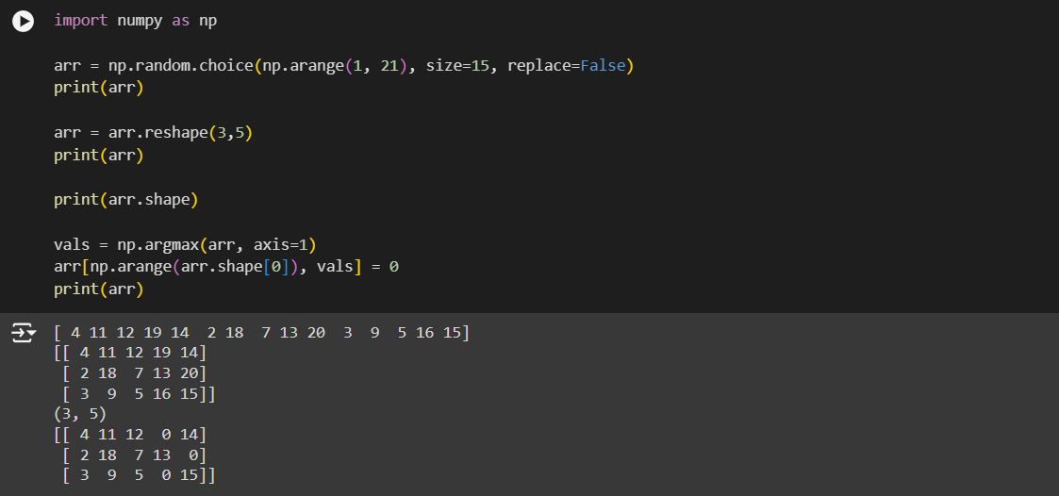

**Description:**

* Creating a 2D array of size 4x3 composed of 4-byte integer elements.
* Printing the shape, type and datatype of the array

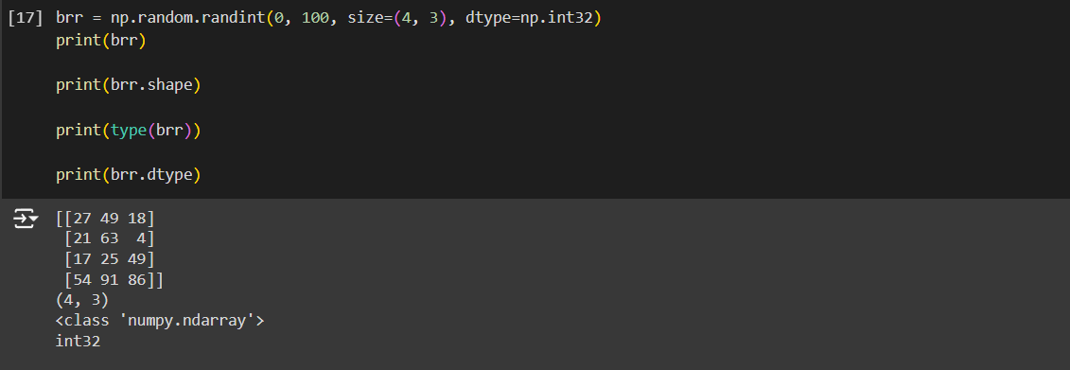

**Description:**

* Computing eigenvalues and eigen vectors for the given array

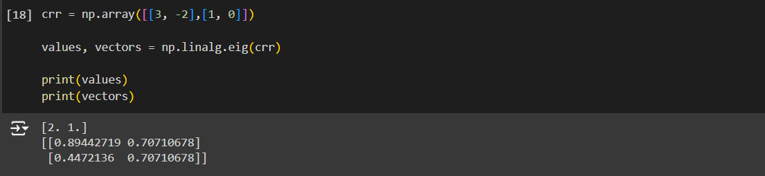

**Description:**

* Computing the sum of the diagonal elements of the given array.

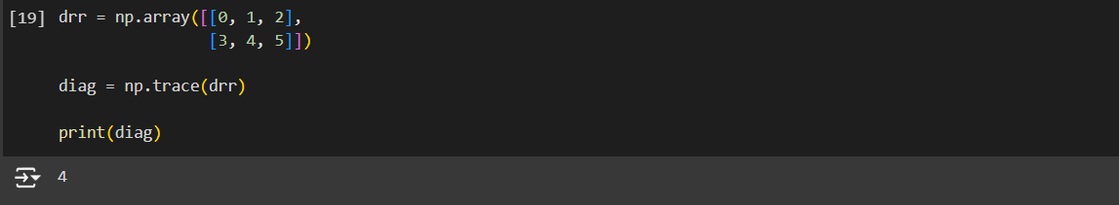

**Description:**

* Creating a new shape to an array without changing the data.

